Art I - Honors Summer Assignment

Due Friday, August 25, 2017

INSTRUCTIONS:

Create a work of art that illustrates your attitude towards summer assignments. Maybe you love it. Maybe you despise it - maybe a little of both.

Material(s) is your choice.

Do not work bigger than an average page in a sketchbook

(9 x 11 maximum)

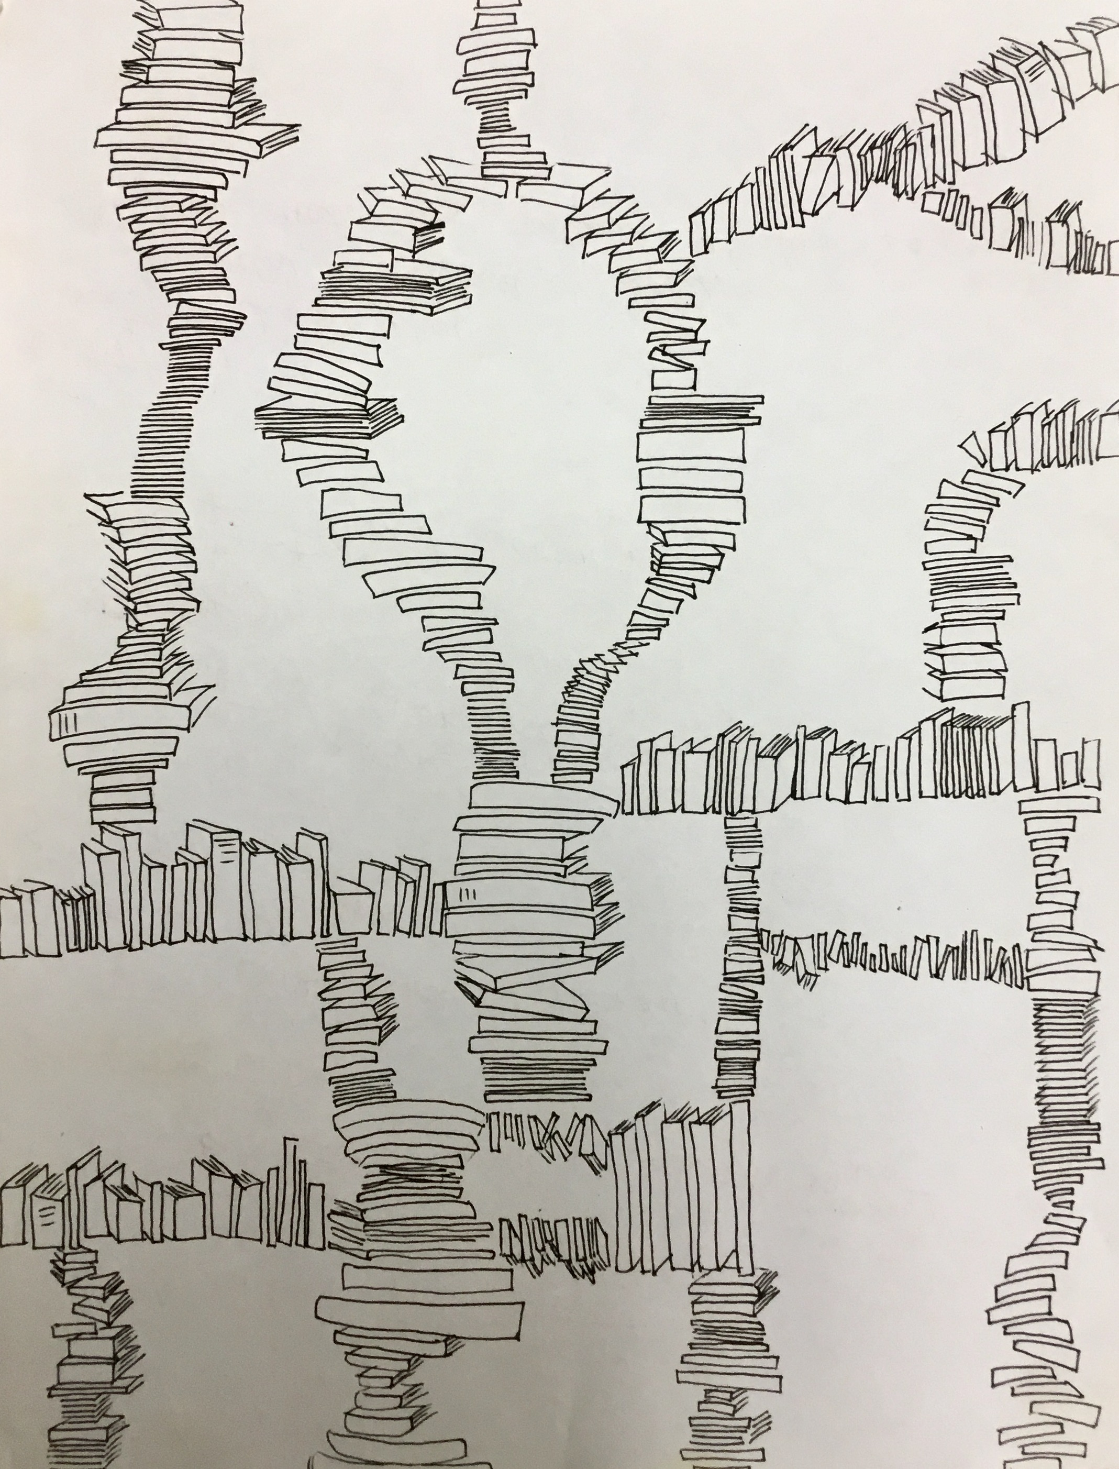

Can you guess how this student feels about his/her summer assignments?

